**Chapter 2 Analysis**

**2.1 Introduction**

* Analysis define any information/realities and data related to assessment/examination to think about the impact of relationship by breaking it into different parts which gives thought for basic decision making and taking care of any related issue.

Analysis is done to assemble date to think about of various data and information realated to the project. Assembling process need certain ability to catch, at that point archive it, work together correspondence with clients and deal with the general necessity. At the time of investigating/ analysing we have to anticipate how data need to be assemble/gather. And aslo the analysis is the procedure of documentaion and identification of requirement related to proposed system of this project. In the analysis phase requirement assembling/gathering is the main aim. And the first step of analysis phase is to analyze and collect various information and date for its feasibility study. And define requirement analysis after that we prepare system modelling like class diagram and use case diagram.

**2.2 Analysis methodology**

* Methodology gives certain rule giving advices on the most skilled method to build up the work.There are various types of methodology they are :- hard system methodology, soft system methodology, and combined system methodology. So I select Soft System Methodology for my project because my project is producing for the necessities of individuals. So I need to concentrate more on individuals' perspectives than specialized. As necessity changes time to time so variability is needed which is given by soft system methodology.

**Advantage :-**

* Improve the understanding as input from client is taken note.
* More individuals cooperation and contribution with the goal that issue is define.

***Various stages can be followed while undertaking soft system methodology:***

* Analyse the information system and produce the rich picture.
* Define root defination and it’s parts of the system
* Prepare the conceptual model.
* Compare idea of the framework with real framework
* Define and select practical choices for improvement
* Execute the new framework

1. **Rich Picture:** It is the illustration that disclose the component identified with the framework and relationship that should be considered so as to make improvement. Pictures, content, image, are utilized to make rich picture. Rich picture perform a view of the various whole system and can allow better arrangement, design, understanding and planning of a system. Rich pictures are generally drawn by hand and incorporate structures, procedures, issues or advancements. It has no rules and guidelines.

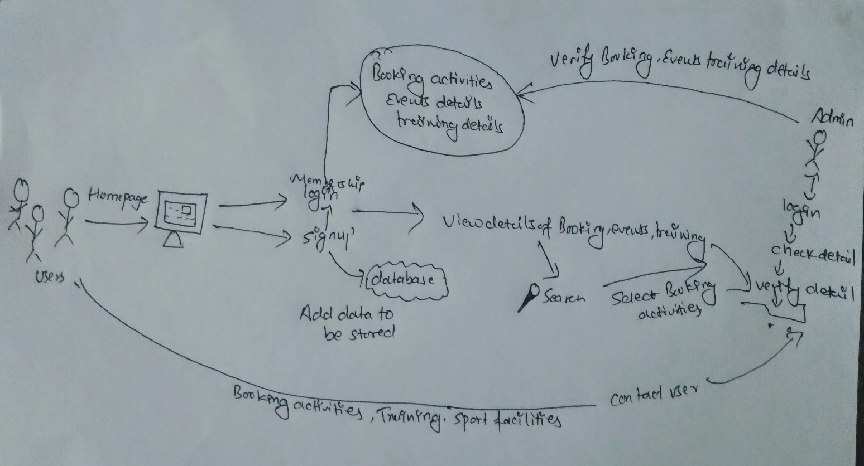

***Fig 1 : Rich Picture***

1. Root defination:- It is an organized depiction of whole framework. It illuminates the System procedures and issue that are held inside the framework. It likewise describe the points and elements of the framework that is being create.

**There are two types root defination they are:**

**- primary task root defination**

**- Issued-based root defination**

**CATWOE:** CATWOE analysis helps when defining and preparing a root definition*.*

* **Customer/Clients:** The primary phase of CATWOE investigation is to characterize these individuals and see how the procedure or framework will influence them. While recognizing your clients, it's useful to address the accompanying inquiries: Who will get the message? What issue do they have? What will be their response? Who are the victors and failures?

Doing your business you should consider your clients every day

* **Actor/Agents:** Actors are the individuals who are in manage of doing the various activities and task. Example:- booking details manage by admin.
* **Transformation:** Transformation are the progressions that framework brings out. The action that gives administration to customers.Example:- User or client can search the details about the activities .
* **World view:** World view clarify why the task and activities exists. Client can arrange the item sitting at the one spot making the item accessible all over.
* **Owners:** The person who is the reason the framework exist. Holder/owner of the project will be administrator who expect to make changes inside framework.
* **Environment:** The environment where the framework works and which may have negative outcomes with the difference in framework. The proposed project is easy to use application making the client work simple and quick.

1. **Conceptual model:** With the help of root defination and rich picture the conceptual model is produce. A conceptual model is a description of a framework, made of the structure of ideas which are utilized to help individuals know, learn, or reproduce a subject the model speaks to. It is additionally a lot of ideas.

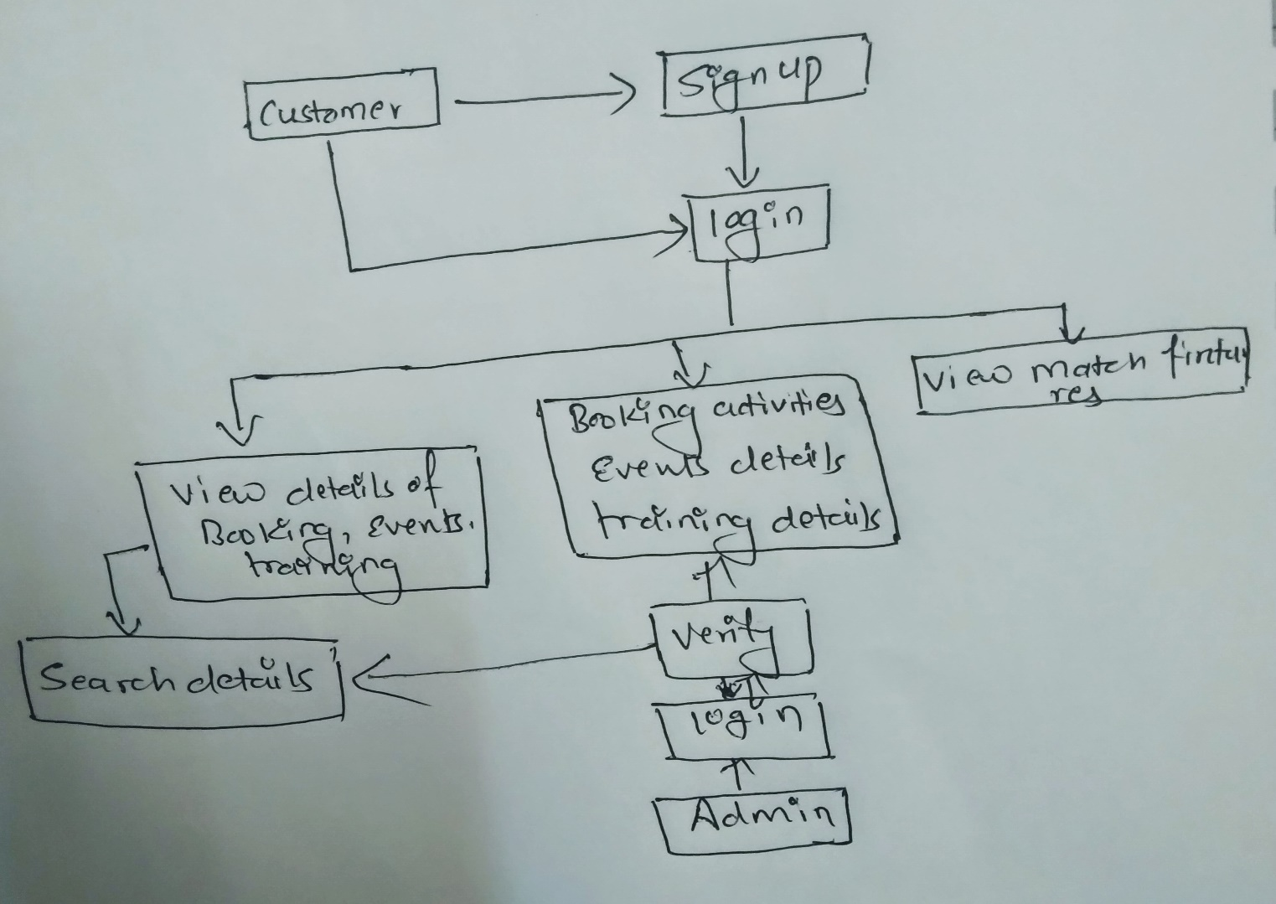

***Fig 2: Conceptual model***

**2.3 Feasibility study**

* Feasibility study is done to know whether the task fits under conditions. The capacity of project, diverse factor to be finished effectively can be estimated by possibility examine. Feasibility study gives the positive and negative results of the project. It give essential details of varuous data and information of the project, likewise it help to recognize the hazard/issues and the arrangement.

The various types of feaibility studiues are shown below:

1. **Economic Feasibility Study:** Economic Feasibility mention to the wellness of the particular task to create monetary benefit/profit.The investigation is otherwise called money saving advantage examination. Here, cost to assemble the project is evaluated, for example, spending plan, distribution, beneficial or not. Given the monetary assets of the organization, is the project something that can be finished? The financial feasibility study is all the more normally called the cost/advantage examination.
2. **Technical Feasibility:** It recognizes whether the equipment and programming asset are practical or beneficial, supportable for the project. The significant viewpoint are recognized which are essential to create the project. For my task, client needs various tools with web office, database server to store item and client data, administrator, site with area name and so forth which are accessible
3. **Scheduling feasibility:** Scheduling feasibility is to check whether the task finishes inside the assigned time. With this practicality think about the task can convey in time. For my project, actual notice was given while selecting time for various task and sub task to finish. Gantt chart and various time estimation were preapred so that it helps the project to be completed in given time.
4. **Legal Feasibility:** legal feasibility is perform to check whether the proposed framework will in general disregard the legitimate principles/rules or struggle with lawful guidelines. It serves to investigations the lawful issue which may influence the task. The project is for scholarly reason (not for business) and doesn't have any issue that contention with the guidelines. Our project isn't against any lawful standards**.**
5. **Operational Feasibility:** Operational feasibility is the measure how successfully the suggest framework can tackle the issues, and satisfy the recognized demand. The executives of the project is welly kept up. The framework task gives satisfactory and reaction time. Expansive number won't be dynamic at once so there is no hazard while working.

**2.4 Requirement Analysis**

* The reports that give a total explanation of the characteristic/conduct of the framework is Requirement analysis. It recognize what the project will perform in every progression and to run what requirement is required.and we have two functional and non-functional requirement to do a analysis.

**2.4.1 functional Requirement**

* Functional requirement bring up the things that system need to do for example conduct/capacities to complete the required work. It explain all the association inside the system which clarify the information sources, output, practices.

Functional requirement for the system are listed below besides its title, Description, Rational and Dependencies.

|  |  |  |  |  |
| --- | --- | --- | --- | --- |
| ***ID*** | ***Title*** | ***Description*** | ***Rational*** | ***Dependencies*** |
| FR01 | Membership Registration | For the login access in the system registration is needed. | For the user personal information and to create an user account. | N/A |
| FR02 | Login | For the access in the system login is needed. | Verify the client to the system that was enlisted/register. | FR01 |
| FR03 | Event submit | Both User and Admin can post their event. | For adding events activities of club. | FR02 |
| FR04 | Event description | Both User nad Admin can post their event description. | For addiing events activities description. | FR02,FR03 |
| FR05 | Update event | Update is required to improved or fix the events submit form | To update the submit events. | FR02,FR03,FR04 |
| FR06 | Delete event | Admin can delete their own events activities. | To delete the events activities. | FR02,FR03,FR04,FR05 |
| FR07 | View event | Both user and admin can view added event. | To view the events activites. | FR02,FR03,FR04,FR05,FR06 |
| FR08 | Training Description. | It is required for providing infromation to user about training facilities. | User can get infromation abour the training facilities. | N/A |
| FR09 | Delete training description | Admin can delete their own Training description. | To delete the Training description. | FR08 |
| FR010 | View training description. | Both user and admin can view the training activities. | To view the training activities description. | FR08,FR09 |

|  |  |  |  |  |
| --- | --- | --- | --- | --- |
| FR011 | Booking sports activites. | User can booked sports activites. | To booked the sport activites. | FR02 |
| FR012 | Update Booking . | Update is required to improved or fix the booking submit form. | To update the booking from. | FR02,FR011 |
| FR013 | Cancel Booking | User can cancel their Booking. | To cancel the booking | FR02,FR011,  FR012 |
| FR014 | View Booking | Both user and admin view the bookin avtivities. | To view the booking activities. | FR02,FR011,  FR012,FR013 |
| FR015 | Link to the socail sites | It is used for the advertisement of bull’s club. | To advertisement of Bull’s club detail. | N/A |
| FR016 | sports facilities description. | It is required for providing infromation to user about swimming and other indoor sport facilities. | User can get infromation abour the swiiming facilities and other indoor facilities. | N/A |
| FR017 | Contact service | It is required for user to contact the staff or admin through phone no or email. | To ask any question or for any help thorugh contact service. | N/A |
| FR018 | Map loaction | It helps user to find out actual loaction of the place. | To find out the loaction. | N/A |
| FR019 | Latest news information | Both user and admin can view all the updated activiteis,events news of bull’s club. | To view the news information of bull’s club. | N/A |
| FR020 | Cookie | It is required to record the user infrormation and data | To store user infromation | N/A |

**2.4.2 Non-Functional Requirement**

* It call attention to the how framework functions or carry on. In another word, it clarify how the framework is performing. It does the testing that clarify how well the framework is

Non-Functional requirement for the system are listed below besides its title, Description, Rational.

|  |  |  |  |  |
| --- | --- | --- | --- | --- |
| ***ID*** | ***Title*** | ***Description*** | ***Rational*** | ***Dependencies*** |
| NFR1 | Response/reaction quickely | System should reaction to the client input. | Provide fast service. |  |
| NFR2 | Usability | Client need to be feel simple to navigate and fell satisfaction | Easily useable and aslo be user friendly | N/A |
| NFR3 | Security | System must guarantee information security and have appropriate access control | to keep away from security issues and increase trust | FR01, FR02 |
| NFR4 | Efficiency | system need to be quick to conduct out the undertaking effectively. | To avoid time loss. | N/A |
| NFR5 | performance | Web based application must to execute as much as expected and have quick information output. | To run system completely | N/A |
| NFR6 | implementation | Test must be done to check the framework./system is right and check the stage/platform. | To make guarantee the framework/system run completely checking each perspective | N/A |
| NFR7 | Reliability | Framework must give exact service. | Reliability service | N/A |
| NFR8 | portability | System must be available from anypalce and from any device. | Available from any device | N/A |
| NFR9 | Documentation | all the project require at least documentation that gives the outline, direction and in general idea regarding how a framework is constructed and how it is utilized. | for the client to learn and think about the framework | N/A |
| NFR10 | Scalability | System must be satisfactory to any change. | Capacity of satisfactory. | N/A |

.

**2.4.3 Moscow prioritization**

* It is know as MoSCoW analysis,or MoSCoW technique and also a it is one of popular prioritization which is use for managing the requirement. This technique is normally used to help key partners understand the importance s of activities in a particular discharge. While dealing with an project, Moscow prioritization is essential to build up a reasonable understanding of the clients' requirement and their need. Numerous project begin with the barest feature rundown of requirement, just to discover later the clients' needs have not been completely understood. And also a It is fast and simple to finish.

The MoSCoW stand for four different categories they are: must-haves, should-haves, could haves, and last won’t have.

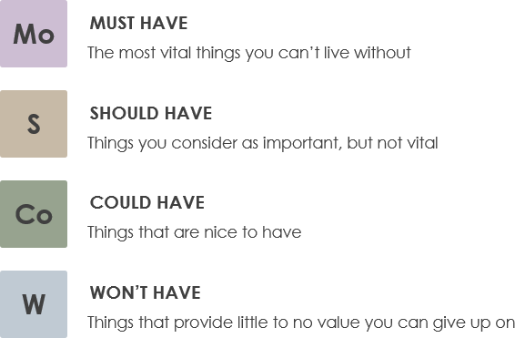

***Fig 3 Moscow prioritization***

|  |  |  |
| --- | --- | --- |
| ***ID*** | ***Title*** | ***MoSCoW*** |
| FR01 | Memebership Registartion | Must have |
| FR02 | Login | Must have |
| FR03 | Event submit | Must have |
| FR04 | Event description | Must have |
| FR05 | Update event | Should have |
| FR06 | Delete event | Should have |
| FR07 | View event | Should have |
| FR08 | Training description | Must have |
| FR09 | Delete training description | Should have |
| FR010 | View training description | Should have |
| FR011 | Booking sports activities | Must have |
| FR012 | Update booking | Should have |
| FR013 | Cancel booking | Should have |
| FR014 | View booking | Should have |
| FR015 | Link to social sites | Must have |
| FR016 | Sports activities description | Must have |
| FR017 | Contact service | Must have |
| FR018 | Map loaction | Must have |
| FR019 | Latest news information | Could have |
| FR020 | Cookie | Could have |

|  |  |  |
| --- | --- | --- |
| ***ID*** | ***Non-Functional Requirement*** | ***MoSCoW*** |
| NFR1 | Response/reaction quickely | Could have |
| NFR2 | Usability | Should have |
| NFR3 | Security | Must have |
| NFR4 | Efficiency | Should have |
| NFR5 | Performance | Must have |
| NFR6 | Implimentation | Should have |
| NFR7 | Reliability | Must have |
| NFR8 | Portability | Must have |
| NFR9 | Documentation | Should have |
| NFR10 | Scalability | Could have |

**2.4.4 Hardware and Software Requirements**

* Hardware requirements are explanation of PC segments/capacities for example storage, Versatility, model and Processor speed. For the best execution of the web utilization of my project the software and hardware requirement are:

***Software***

* **Operating System:-** Windows 10, 8
* **Database:-** MySQL
* **Browser:-** Internet explorer, Google Chrome, Mozilla Firefox
* **Microsoft office**
* **Star UMl**
* **XAMPP**
* **Sublime TEXT**

***Hardware***

* **Laptop** (DELL)
* **Harddisk:-** atleast 8GB
* **RAM:-** atleast 6GB
* **Processor:-** Minimum 2.30 GHz intel® core™ CPU @ 1.60Hz dual core

**2.5 Use Case Diagram**

* The behavior diagram which is an illustration of user interacting with the system to achieve goal providing overview the relationship between user and variety of use cases (event/list of actions).This process is “**use case diagram”**

The advantage of creating this diagram on my project are as follows.

* It is an easy and understandable method of representing a system to the local people since it doesn’t have any technicality.
* Use cases evolve with each iteration and change in requirements can be traced easily.
* It shows the relationship of these entities with different functionalities. //

Use diagram of my project is shown below:

1. ***User Membership Login System***

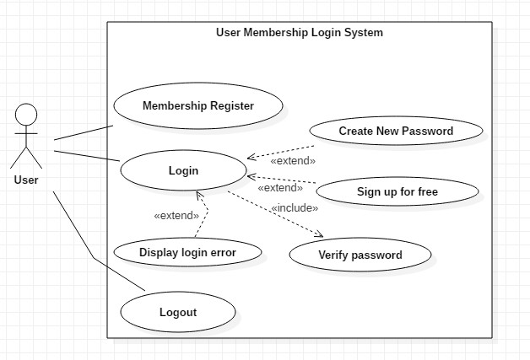

*Fig 1 User Membership Login System Use Case Diagram*

Unregistered users will have to register their account first to create and Membership account. After they are registered, they can login to the system. If in any case, the user forgets their password or need to sign up with another account, they can create a new password or sign up for free respectively as shown by the extend relation and also when they try to login to the system first of all system verify the user password if its right than only system give permission for login or if user enter the wrong password then system display the login error so as shown by the extend relation.//

1. ***Admin Login System***

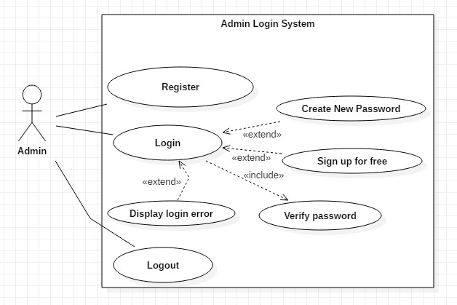

*Fig 2 Admin Losin System Use Case Diagram*

Users at first need to be registered as admin. After they are registered, they can login to the system. If in any case, the admin forgets their password or need to sign up with another account, they can create a new password or sign up for free respectively as shown by the extend relation.//

1. ***Event Submit Use Case***

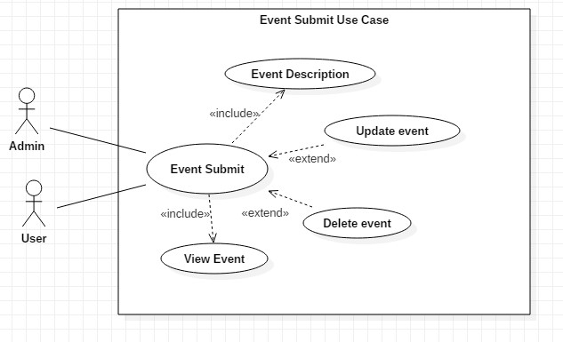

*Fig 3 Event Submit Use Case Diagram*

Both user and admin of the system who can perform event submit activities. In this event submit activities both admin and user can write the description of event.and the update and delete opertaion is mainly perform by admin in which admin can manipulate user submit form. And at last both admin and user can view overall event activities in the system respectively as shown by the extend relation.

1. ***Training Description Use Case***

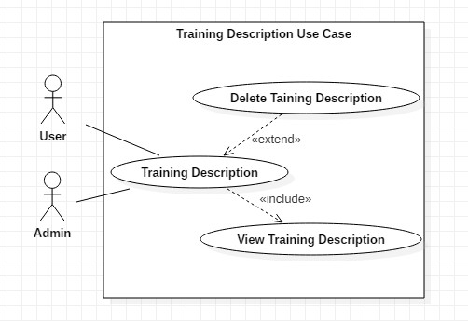

*Fig 4 Trianing Description Use Case Diagram*

Both user and admin of the system who can perform Training Description activities. This activities mainly perform by admin in which they can add various infromation and knownlege about training facilities which was given in their Club. So they allow user and admin itself to view their training facilities decription.and also the delete opertaion is mainly perform by admin in which admin can control training activities part respectively as shown by the extend relation.

1. **Bull’s Club Booking Use Case**

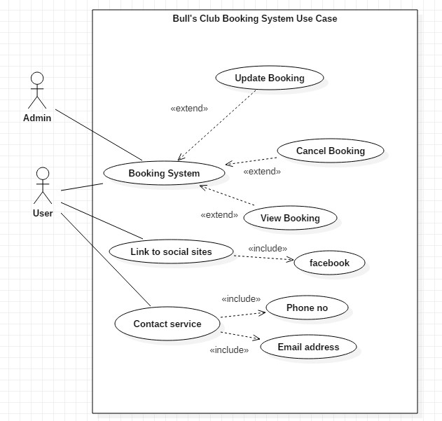

*Fig 5 Bull’s Club Booking System Use Case Diagram.*

Both user and admin of the system who can perform Booking System activities. In this Booking actvities when the user booked the sports and later on user want to cancel the booking they have option to do It otherwise, admin will also have option to do it if user say to cancel it. And both admin and user can view overall Booking activities in the system. And also the update opertaion is mainly perform by admin in which update is required to improved or fix the booking form. User can booked the sports not only from booking system but also from the social sites like fb and contact service like phone no and email address in which they can send msg for booking or they can call to staff for booking activities so this part respectively as shown by the extend relation.6

**2.6 NLA (Natural Language Analysis)**

* NLA (Natural language analysis) helps to do analysis and identify classes. We pick out the noun, verbs and adjective from the scenario given. completely understandable to non-technical people is known Natural Language Analysis. It revolves around an unstructured text where nouns are selected as potential object candidates, verbs are selected as potential candidate methods and adjectives are selected as potential attributes.//

Bull’s Club Swimming is loacted at Nakhu,Lalitpur which has been providing good quality of swimming facilities to the people. The owner of Bull’s Club wants to make a web-based application system to expand business as well as for advertisement of club in order to provide information to the people about Bull’s Club. So that’s why I am creating a web-based application sytem for Bull’s Club.

The sytem will allow users and admin to register their detail and signup to create a new account. So as customer can create an Membership account/registration and login with registered username or email and password. So they can get access right. In order to login users are required to insert some of their personal data. Admin will also have ability to add users if any case the users lacks of proper technologies. If users and admin forget their password a feature of creating new password is provided by the system. Once the user is into the system, they will have to ability to post the event, and has ability to write description about the event activities as well ability to delete and view of event. Besides, event they have ability to view the training and sports faciliteis description. Also also the online booking system will also be available for users where they can booked indoor club sports activities as well as they can cancel and view the booking. Not only the users are perform the system activities but aslo the admin perform the various system activities like admin can add, update, delete, cancel and view the event, training, sports and booking activities. If user have any problem or any question for ask they can use socail sites link like fb or contact service like email or phone no.

From the above senario, the Natural Language Analysis is perfomed separating the noun( for candidate classes), adjective (for the attributes), and verbs (for the operation).//

|  |  |  |
| --- | --- | --- |
| ***Nouns*** | ***Verbs*** | ***Adjective*** |
| Account, Customer, Registration, match, login, service, admin, user, training, event, sports, booking,system,facilities,activities | Update, delete, add, view, Calculate, cancel. | Email, username, password, comment, Score. |

`

***Candidate class***

1. Admin
2. User
3. Events
4. Booking System
5. Training Facilities
6. Sports Facilities

**2.7 Intial Class Diagram**

* The design of relationships and code (source) dependencies between classes is defined by **Class diagram** (Rouse, TechTarget, 2007). This class diagram helps implementation the system in OO language which gives knowledge to create the connection between classes. Also, it is a Structural diagram that outline the structure and view in terms of classes, attributes, methods and relationship between a classes. Classes contain different access level control by the access modifier. I.e. Public (+), private (-).

The initial class diagram that is develop with the help of NLA with main classes, attributes and methods for Bull’s Club Swimming Pool management system is below: